AKS istio:

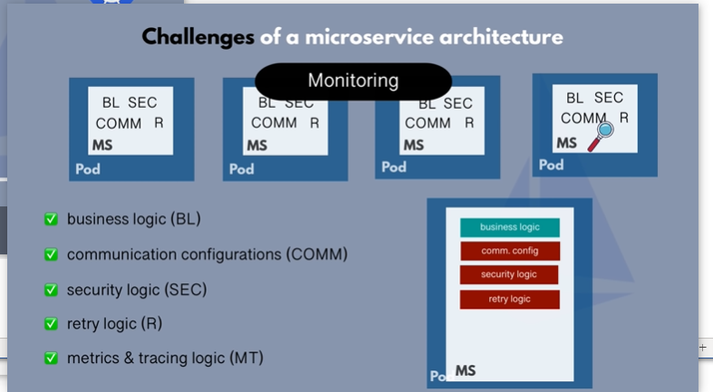

The bod have proxy pod will communicate via on that proxy.

CRD 🡪 custom resource definition.

[Service Mesh - the Microservices in Post Kubernetes Era · Jimmy Song](https://jimmysong.io/en/blog/service-mesh-the-microservices-in-post-kubernetes-era/)

